
Name:

11 Physics
Electricity
Topic Test 2015

Score: _________ / 50 ______________%

TIME ALLOWED FOR THIS TEST
Working time for this paper: 50 minutes

MATERIAL REQUIRED OR RECOMMENDED FOR THIS TEST

This question and answer booklet
Physics Formula & Constants Sheet
Pens, pencils, eraser, rule, Mathaid or Math-o-Matt
Scientific calculator

INSTRUCTIONS
Answer all questions and write answers in the spaces provided.
Numerical answers should be evaluated with three significant figures unless otherwise stated and given in scientific notation.

1. A 6.00x102 W microwave oven is operated using the 240 V mains supply. What current does it draw?

(1)

2. A cassette player's rechargeable battery supplies 12.6 joules to 10.0 coulombs of charge which pass through it. What potential difference does the battery provide?

(2)

3. A common metal wire of length 19.3 m and diameter 0.150 mm has a resistance of 17.1 Ω.

(a) Calculate the cross-sectional area of the wire.

(2)

(b) Determine the resistivity of the metal.

(3)

4. (a) Why is it potentially dangerous to operate electrical appliances (such as hair dryers) in a bathroom?
(Assume the appliances use 240 V mains electricity.)

(2)

(b) Why is it not advisable to have several high current devices and appliances (e.g. heaters, fans, etc)
operating form the one power point in a house?

(2)

5. What is the cost of running a 5.50 x 10² W refrigerator for a year if it operates an average of 8.25 hours per day
and electricity costs 14.2 cents per unit? (1.00 unit = 1.00 kWh = 3.60 x 10⁶ J)

(3)

6. How much heat energy is dissipated by a 48.0 kΩ resistor that has a current of 0.350 A flowing through it for a
time of 40.0 minutes?

(4)

7. Determine the total resistance in each of the simple circuits shown below.
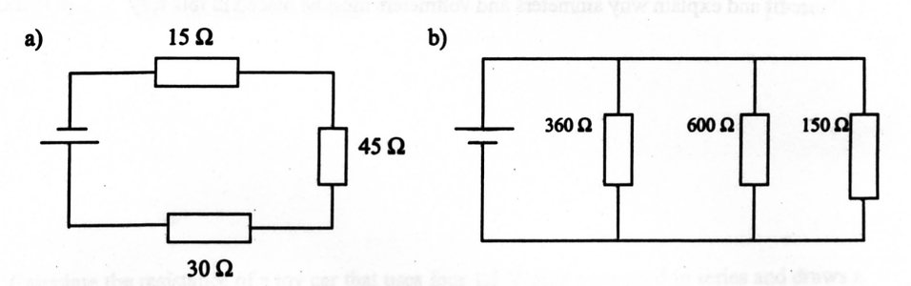

(3)

8. Describe how the following act as safety features to protect people from electric shock.

(a) Fuse

(b) Earth wire

(c) Double insulation

(3)

9. The circuit below shows a complex circuit with 25.0 mA of current flowing in the 100 Ω resistor C.
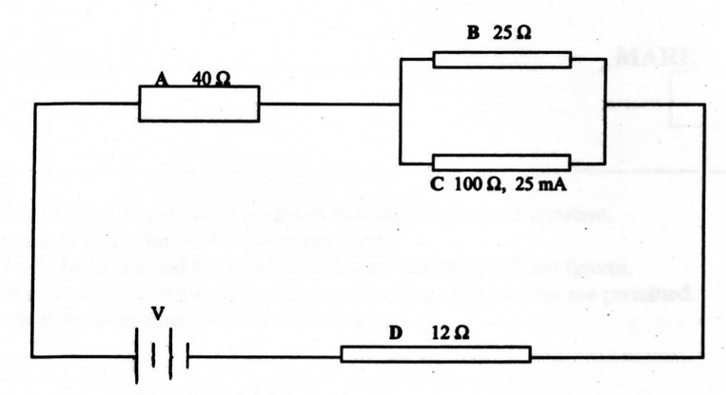

(a) Find the potential difference across resistor C.

(2)
(b) What is the current flowing in resistor B?

(2)
(c) Determine the total current flowing in the circuit.

(2)

(d) What is the effective resistance of the circuit?

(3)
(e) What is the potential difference of the electricity source?

(2)

10. The cost of electricity is 13.7 cents per unit.

(a) What are you paying for?

A) Power
B) Voltage
C) Current
D) Energy
(1)

(b) A 1.20 kW kettle takes 4.37 minutes to boil. How much does this cost?

(3)
11. A group of students were given the task of determining the value of an unknown ceramic resistor. Their results
were as follows.

Voltage (V) | Current (A)
1.95 | 0.75
3.80 | 1.55
6.15 | 2.50
8.00 | 3.10
9.85 | 4.00

(a) Draw a circuit diagram to show how the students would measure the voltage and current through the
resistor.

(3)
(b) Graph these results on the grid provided.
(3)

(c) Determine the gradient of the graph and hence the value of the resistance.

1. Sometimes, when a person gets out of the car during summer, they get "zapped" by an electrical discharge
when they touch the metal door. Explain why this occurs, including how the person may have become charged.

(3)

2. Draw the electric fields associated with the following.

(a) (b)
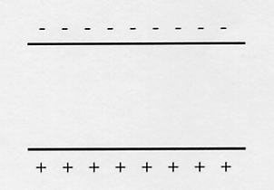
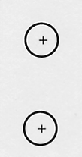

(4)

3. In the electron gun in a typical colour TV tube, the potential difference used to accelerate electrons is 15.0 kV.
Calculate the speed at which electrons leave the gun, assuming that they have no speed as they leave the cathode
(negative electrode) inside the gun.

(3)

4. The diagram below represents a cathode ray tube that accelerates electrons between its electrodes. Each second,
3.12 x 10² electrons move between electrodes X and Y. The accelerating voltage is 5.00 x 10² V.

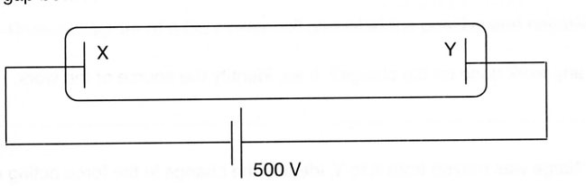

(a) Draw the direction of the electric field in the tube. Explain why you chose this direction.

(2)
(b) Determine the size of the current that flows.

(3)

(c) Calculate the speed of the electrons as they reach the opposite electrode.

(3)

(d) What is the power developed by the power source of the tube?

(3)

5. At a Science show, a large sphere carrying a charge of - 3.60 μC is placed at the base of a vertical tube
in an "electrostatics experiment". A small 2.31 g sphere with a charge of - 1.00 μC is dropped into the
vertical column and is repelled by the large sphere so that it floats above it. Assume no charge is "lost'
to the tube.
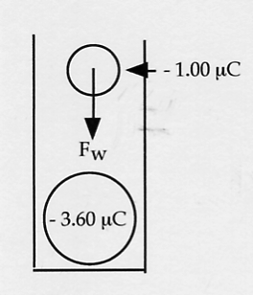

(a) What is the force of gravity on the small sphere?

(2)

(b) Use your answer to part (a) to calculate the distance between the two spheres when the small
sphere stopped moving.

(3)
(c) Calculate the number of excess electrons on the small sphere.

(2)

6. Two small objects, 0.150 m apart and carrying identical positive charges, experience a force of repulsion of
32.4 N. Calculate the magnitude of the charge on each object.

(4)

(3)

END OF TEST ☺

